1. **Setting up a free trial BTP account:**

* Visit **SAP** website to make an account if you don’t already have one.

<https://www.sap.com/mena/index.html>

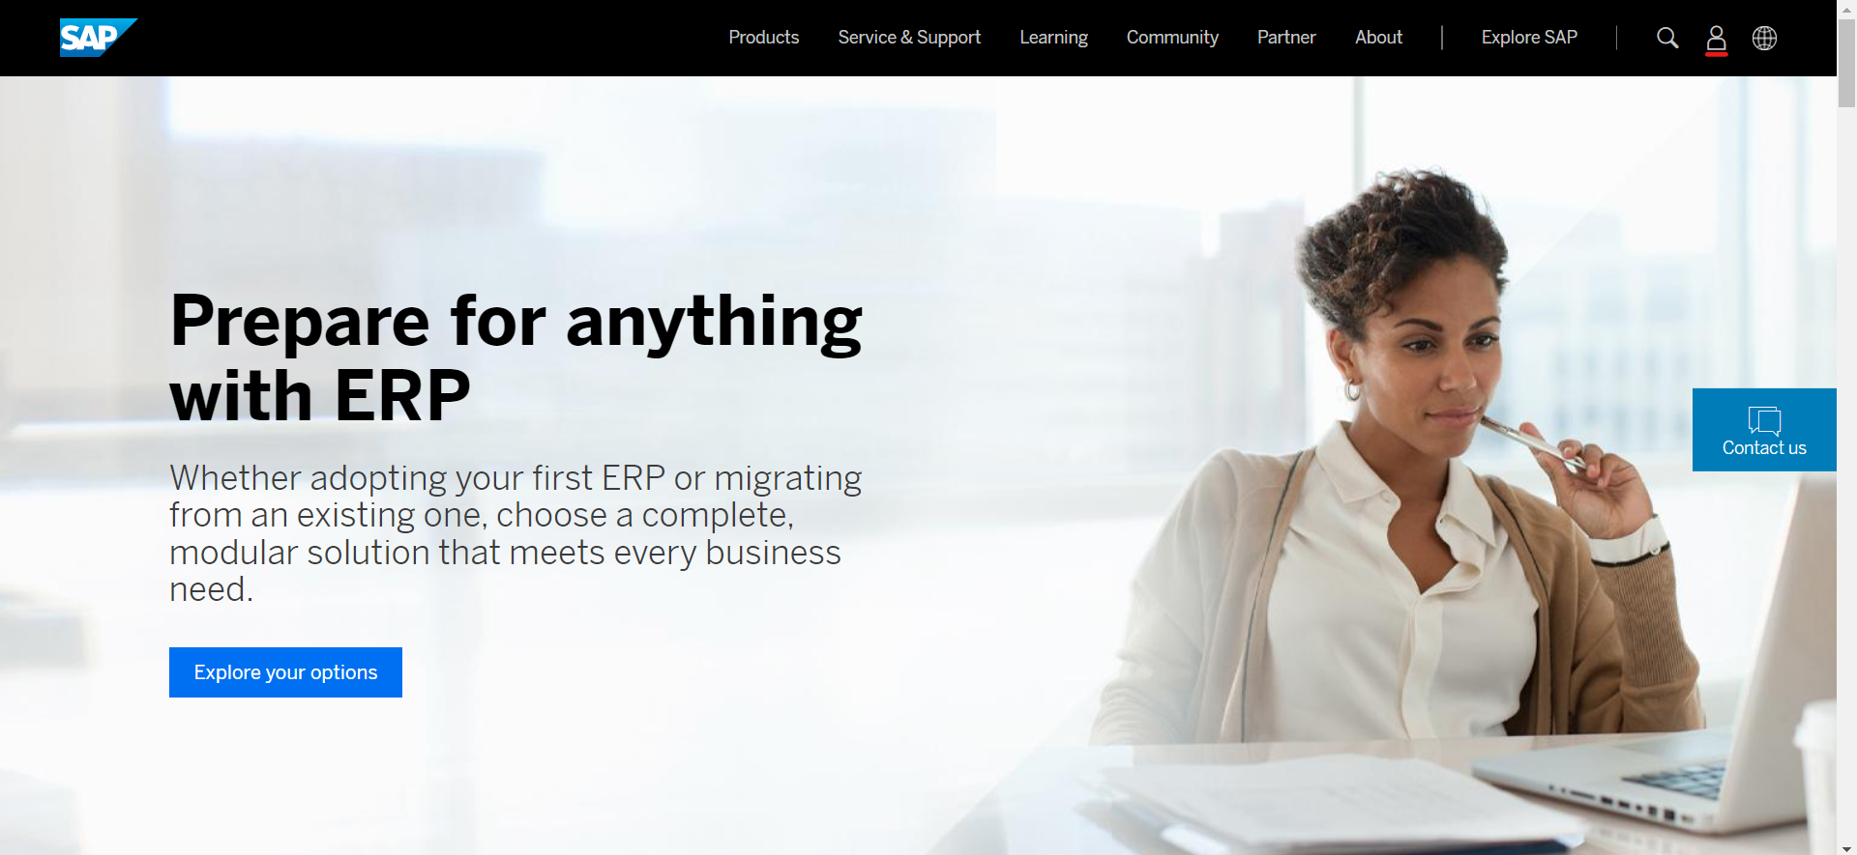

* Press on the **profile** icon in the top left corner and start the registration process. Fill out your information, then activate your account through your email.

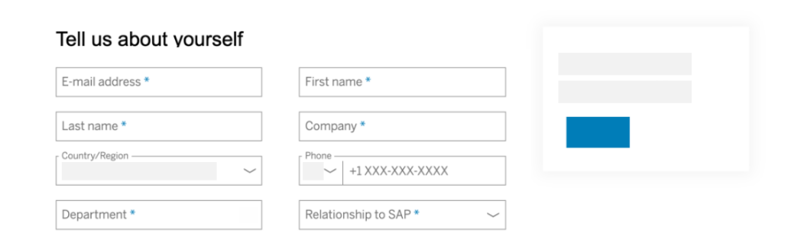

* After activation, go to the **BTP Trial page**; <https://account.hanatrial.ondemand.com/> , and log on with your SAP account credentials.

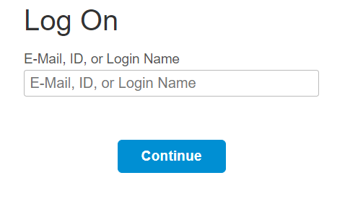

* Verify your account using your phone number, after verification you will be logged off.

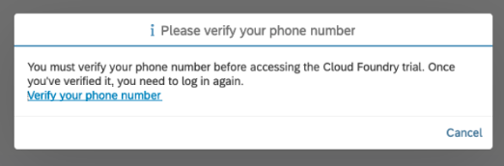

* Log on again onto your verified account, click **Go To Your Trial Account** to access your global account.

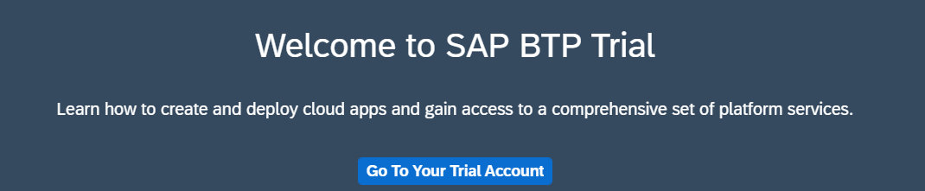

* Navigate to **subaccount**, choose any region from the list and click create account.

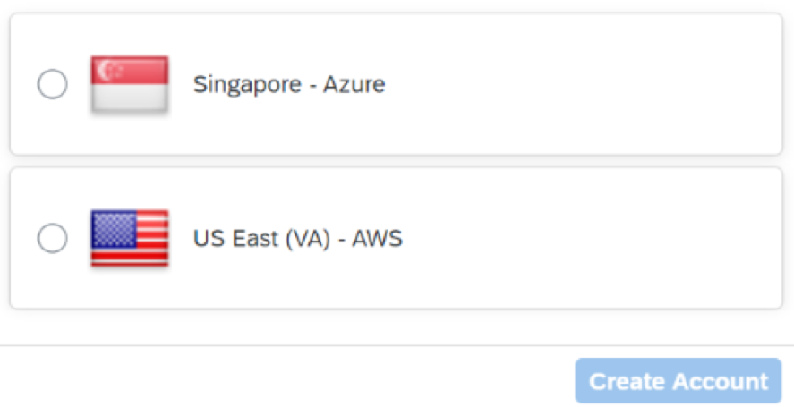

* Your account is set up you can now access everything by clicking on the subaccount. Take a look around to get familiar with everything and don’t forget to bookmark this look for easy use.

1. **Linking BTP with Build Process Automation:**

* Open your BTP account and go to **Service Marketplace** and type Build Process Automation in the search field.

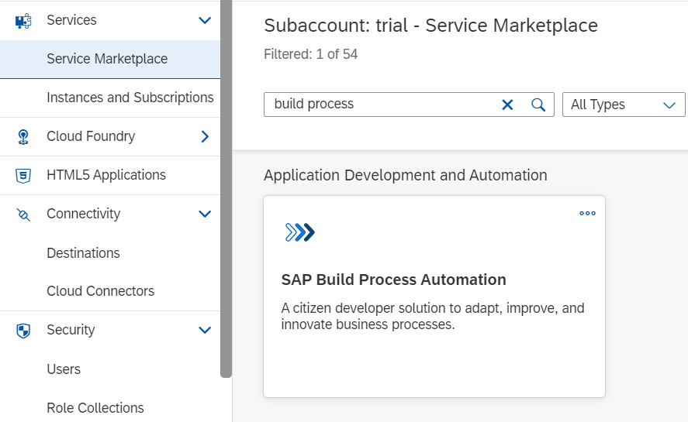

* If you don’t find it in **Service Marketplace.** Go to **Entitlements** from the left menu.
* Choose **Configure Entitlements, Add Service Plans.**

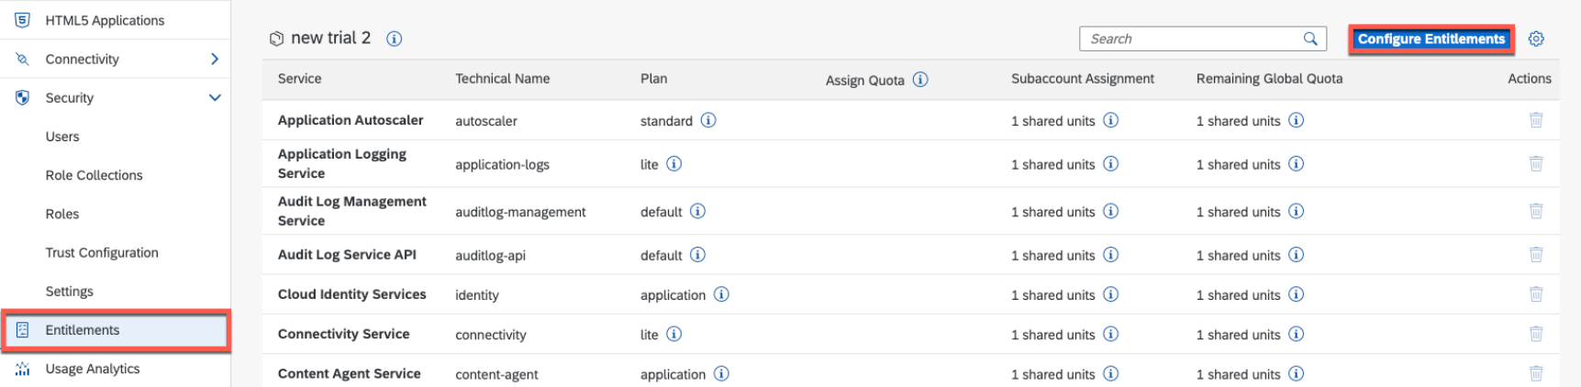

* Search for Build Process Automation; **Select free plan, Click Add Service Plan and Save Changes.**

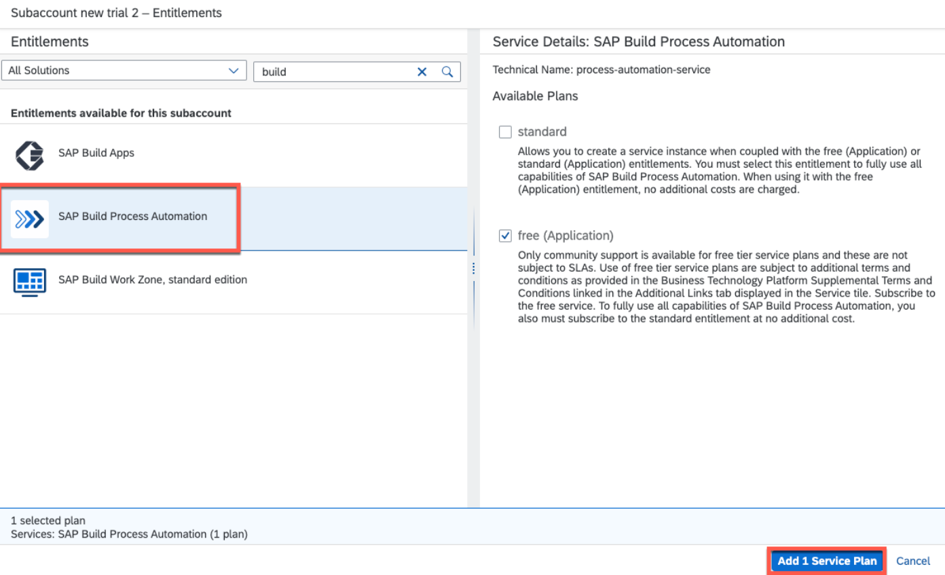

* Otherwise, if you find it in **Service Marketplace;** Click on it, then click **create**

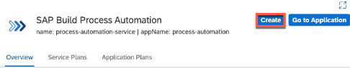

* Choose the **Free subscription** plan and click create.

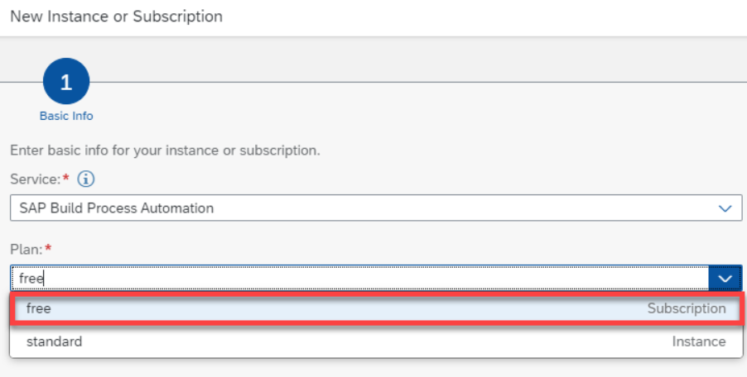

* From the left menu, choose **Users** under Security.
* Select your user, go to the right in Role Collections.
* Click on **Assign Role Collection.**

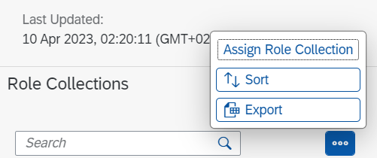

* In the search bar type Process, select these 3 roles; **Process Automation Admin, Process Automation Developer and Process Automation Participant**.
* Click **Assign Role Collection**.
* Finally go to Instances and Subscriptions from the left menu and from there you can access the build automation application by the go to application icon.

1. **Downloading and Setting Up Desktop Agent:**

* Download the latest version from here; <https://tools.hana.ondemand.com/#cloud>

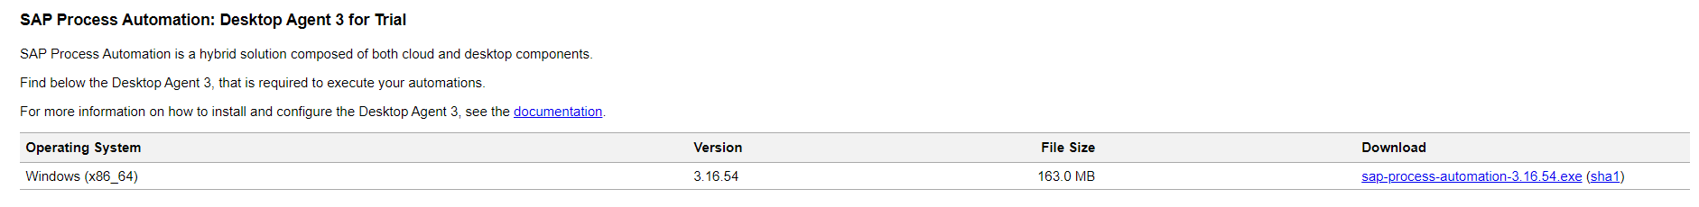

* Start the installation process, once it’s finished enable the google chrome extension for the desktop agent.
* Open **SAP Build** homepage and go to settings, choose agents from the left menu and click Register new agent
* **Copy** the URL from the pop-up and close

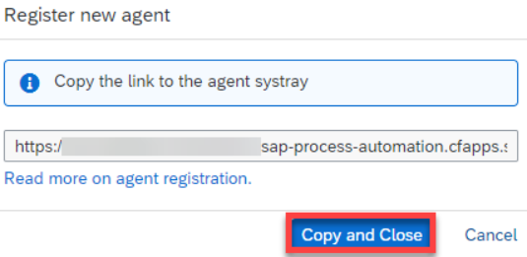

* Open the desktop agent, click on **Tenant** and in the **domain** field paste the URL

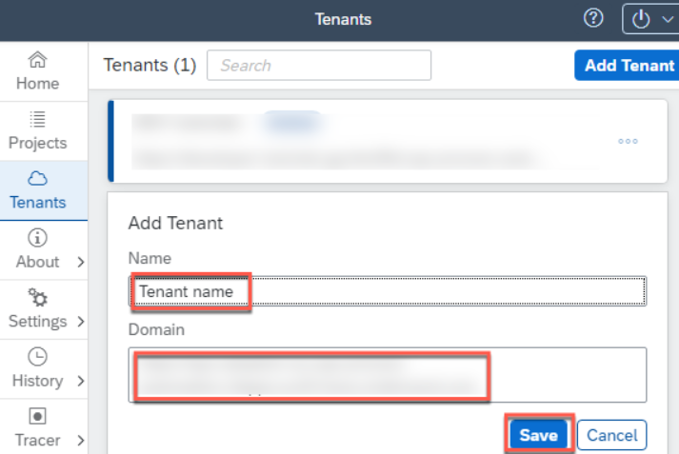

* **Add** the tenant and **activate** it.
* You will be asked to log in again then it will be activated.
* You can check by going back to your agents’ page and making sure that it’s there.
* Go back to Build page, Agent Management, choose you argent and **add** it.

1. **Outlook Automation Tutorial :**

* This is a simple automation tutorial where the desktop agent goes through our outlook and searches for something that we set.
* Go to **Build** homepage and choose create automation, from the left menu add dependencies. Type **Outlook SDK** and add it to your project.
* This is the **Tool Panel**, we will be using it constantly to access all the activities we want.

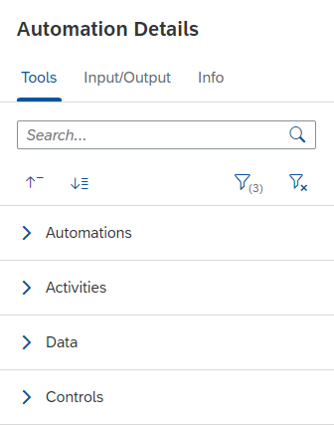

* Search in it for **Open Outlook Instance**, to open Outlook on our desktop. Then drag and drop it into our automation.
* Then type **Search Email** into the panel and also drop it into the flow.
* Click onto the Search Email activity to select its parameters, click on **create custom data** and here you can select the parameters you like to search your email with. In my case I’d like to search with the subject of the email.

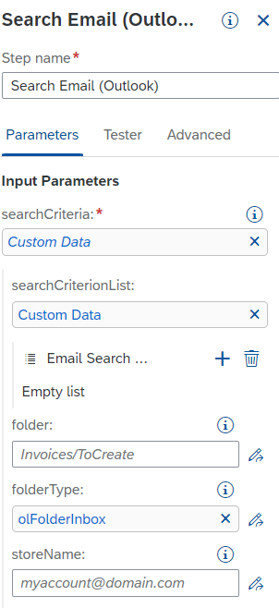

* Then I output a message just to show how many emails I have in this folder by putting the **Log Message** activity into the flow, you can click on the activity and edit the message being shown however you want.

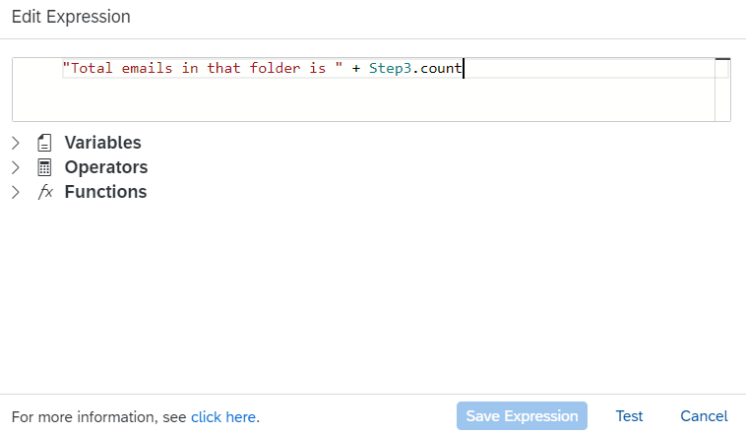

* Then I put the **Forever loop**, which loops until a condition comes that isn’t true and stops it.
* After it we put the **Check Current Email** activity, then a Condition which says that if an out of context email comes, then we put a **log message** saying that there are no more emails in this search context.
* And in the **default** branch the looping continues and we keep printing the mail number and the mail subject just for us to know.
* **Overview** of the automation

